In order to prepare for the process we first need to send a FOIR (Freedom Of Information Request) via email to your local county and/or district council via the link below:

https://www.whatdotheyknow.com/select_authority

Once you have entered your council, in this instance its Suffolk County Council, you will need to fill in the Summary field. The suggested text is:

Freedom of Information request - Regarding 5G installations and 15/20 minute neighbourhoods

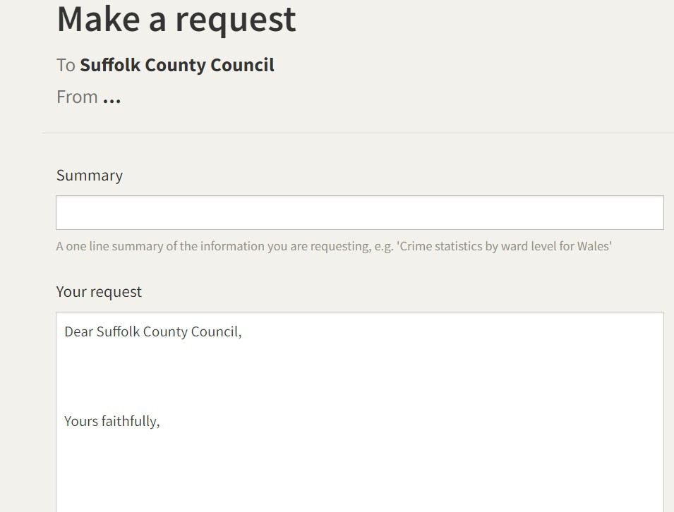

Dear your Local District Council will then automatically appear under “Your request”.

You will then need to copy the text below, and insert it into your request, DO NOT FORGET TO REPLACE THE TEXT IN RED WITH YOUR OWN LOCAL DISTRICT OR COUNTY
COUNCIL, depending on which one you have chosen to make the request to. (You can choose to make a request from either your Local District Council or your County Council or both councils).

This is a freedom of information request. Could you please supply the following information:
- The location of 5G masts that have been installed throughout Your District/County.
- The locations of all planned future 5G masts to be installed throughout Your District/County.
- Specification sheets of all 5G technology installed or planned to be installed over the next five years.
- What technology e.g. units and arrays that are not currently 5G, but could be 5G enabled after software, hardware upgrades or retrofitting?
- The locations of all small cells (low-power access points that operate in any licensed spectrum) and where they have been installed?
- What small cell low power access points are planned to be installed in the next five years?
- The names of companies and entities involved in these installations and the names of the company/entity officers.
- What information has been made publicly available about the potential health effects of the above installations, such as the safe levels of exposure to non-ionizing microwave radiation.
- The name of the company insuring any claims for negative health effects associated with the above installations.
- Any impact assessment regarding low traffic neighbourhood areas or 15/20 minute neighbourhoods and how this would restrict free movement.

Finally it is essential to enter your name below “Yours faithfully”.

A .pdf of your request will be emailed to you. Please print and save a copy of this for your records.

