Jonathan L. Trapman

Jonathan L. Trapman, author and photographer, has written since aged 9 and photographed professionally since aged 16.

Following reaction from early enthusiasts, his classmates, his professional career took off in 1972, having completed a diploma course at the world famous Central London Poly School of Photography.
Launching into a short but illustrious career in photo journalism with such Fleet Street titles as The Times, Observer, Daily Express and Sun - seeing him scoop royal images, celebrities and regular people, he found no enjoyment in intrusive "foot in the door" and “make up the copy to fit the picture” necessities of photojournalism. He moved swiftly on into the world of advertising and commercial photography.

This enabled him to accomplish a long held dream of travelling the world, meeting all types from royals to ordinary folk, expanding his language base to five languages. Keen to communicate with all those he photographed he always made sure he had a basic skill in more.
Becoming renowned as one of the industry’s foremost photographers he enjoyed getting to know the world, its peoples and a far wider vision of life on earth on others’ behalf and at others’ expense among the heady environs of the advertising industry. Through the 70s, 90s and early 2000s he worked for many blue chip companies and corporations including British Airways, BMW, Piaggio, Gallaher Group, Chivas Regal, Times Newspaper Group, Marks and Spencer, Citygroup, Fujitsu, Kodak, British Petroleum, Wimpey, Balfour Beatty, Ford Motor Company, American Express, Nestlé, Sony, Proctor and Gamble, Johnson and Johnson and many others.

He has appeared on TV and radio including the BBC, France Inter and online radio. He has been invited to speak at creative and literary conferences across the globe including a recent UNESCO sponsored international conference in Ankara Turkey.

Early 2012, in partnership with his wife, had him accomplish several translations of foreign writers. The most enduring, endearing and groundbreaking has been the first ever, in over 900 years, translation of 10th century Sufi founder and mystic saint Hoja Ahmed Yassawi’s Diwani Hikmet (Divine Wisdom) poetry and sacred verse.

Currently authoring The Freedom Cycle an ambitious heptalogy (seven book) project, Dreams and Realities is the first off the press. With the second volume, Angel of Redemption, due out 2019/20 and remainder set to roll out over the next few years.
Jonathan was part of the core team enabling the advancement for Visual Artists rights in copyright and successfully strengthened copyright ownership for all visual artists from the 1990s. His travels in Europe, Russia, Kazakhstan and the USA over the last ten years helped him develop exhibition materials and an education base, where his heart is mainly focused today.

His photographic Legacy Archive Exhibition world tour of Shoot, Learn, Grow - An Evolutionary Journey - Life Lessons Through the Lens is set to take in Rome, Florence, Brussels, the Baltic States Estonia, Latvia and Lithuania, Russia, Moscow St Petersburg and Sochi, Kazakhstan, Astana, Almaty and Turkestan, China, Beijing/Shanghai, Tokyo, Australia and New Zealand, San Diego CA USA, Vancouver, Toronto in Canada, Brazil and the UK

His work has appeared in press and magazines worldwide including publishers such as Condé Nast, IPC, Arena, Times Newspapers and Macmillan.

His partnership and work with Gene Nocon, one of the world's foremost photographic printers enabled them both to work to educate and inspire several generations of photographers and creative artists.

His work has been exhibited in New York (Madison Avenue), Amsterdam (Canon Gallery) London (AOP Gallery, Barbican and Medici Gallery, Cork Street) Tokyo (Dentsu), Paris (Champs Elysees), Arles, Provence (JIP/Rencontres d’Arles)

As one of the founder members of the Association of Photographers, one of the industry's top global professional photographers organisations, he worked with Kodak, Mamiya, Fuji and Nikon in helping educate and inspire would-be photographers and professionals alike into the industry.

Currently living in Somerset UK he continues to author and photograph.

Published books:
Shoot Learn Grow – An Evolutionary Journey – Life Lessons Through the Lens 2018
Dreams and Realities – Volume 1 of The Freedom Cycle – 2016
Divine Wisdom - Poems of Hoja Ahmed Yassawi 11th century Sufi Poet and Saint – Diwani Hikmet - 2013

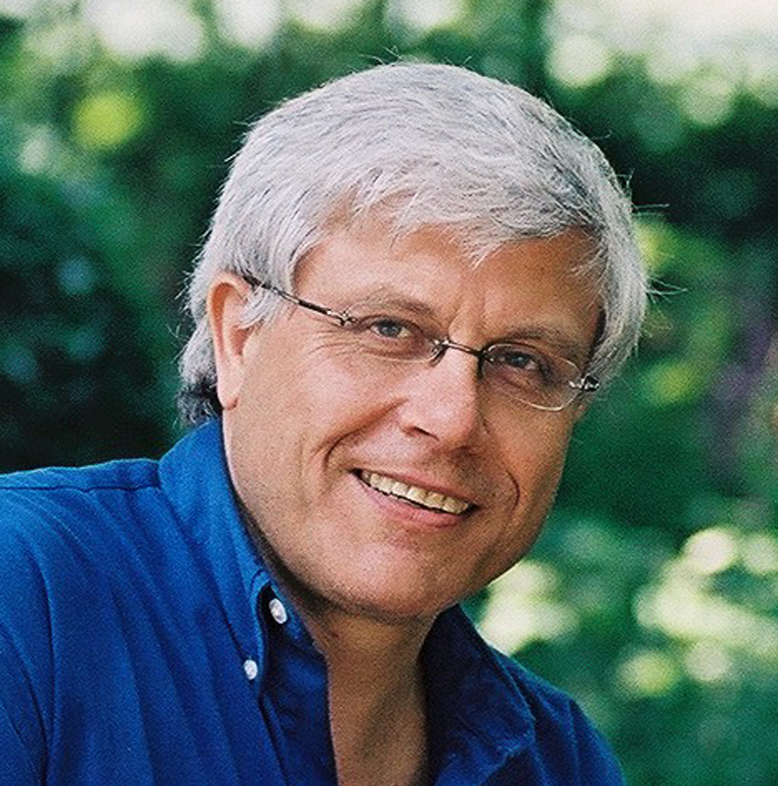
Contact Jonathan:
Email: media@thefreedomcycle.com
Web: www.thefreedomcycle.com
Tel: UK – (44)(0)-7817892900
USA – (1)-864-372-4820
Skype: jonathantrapman
FaceTime:
j.trapman@zen.co.uk
FaceBook: totothebook

